Jerry Olds

1001533643

CSE-4308-002

7/17/2019

Assignment1

**TASK 2**

Breadth-first search: Bremen, Hamburg, Hannover, Dortmund, Luebeck  
Depth-first search: Bremen, Hamburg, Luebeck, Hannover, Magdeburg  
Iterative deepening search: Bremen, Hamburg, Luebeck, Hannover, Magdeburg  
Uniform cost search: Bremen, Hamburg, Luebeck, Hannover, Magdeburg

**TASK 3**

1. Breadth-first search, uniform cost search, and iterative deepening search
2. No it is not a one-to-one correspondence because a node in the search tree can correspond to two different vertices in the SNG
3. 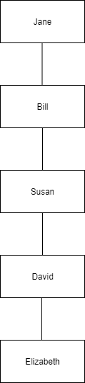
4. Form the search in such a way that the tree will be linear with no branching.

**TASK 4**

Heuristic 1: Non-admissible

h(A) = 25

h(B) = 35

h(E) = 20

Heuristic 2: Non-admissible

h(A) = 25

h(B) = 35

h(C) = 5

h(D) = 0

h(E) = 20

h(F) = 60

Heuristic 3: Non-admissible

h(A) = 25

Heuristic 4: Non-admissible

h(A) = 25

h(B) = 35

h(C) = 5

h(D) = 0

h(E) = 20

Heuristic 5: Admissible

**TASK 5**

City -> Suburb -> City and farm -> farm and mountain

1 2 3 4 5 6

H = 6